Independent Project Progress Report

Names: Jane Babiak-Abray, Nathaniel Bechard

Part 1 (video of movement capabilities submitted separately)

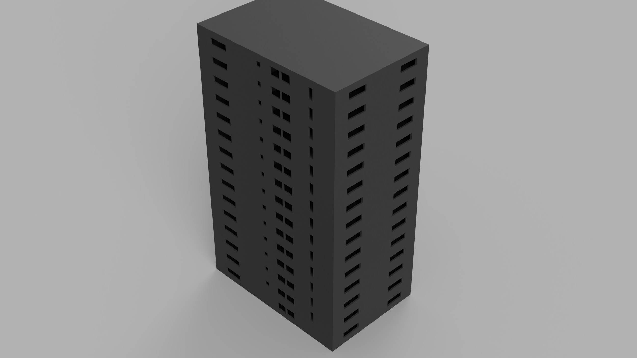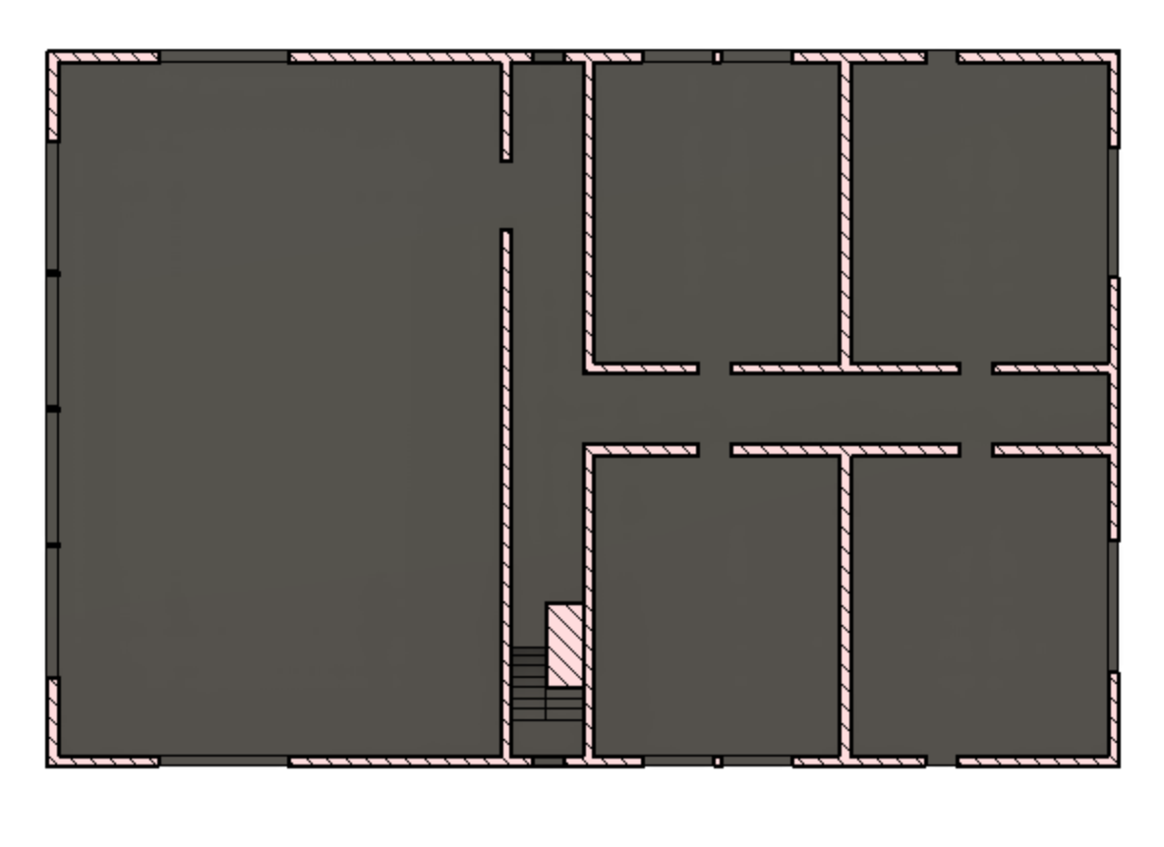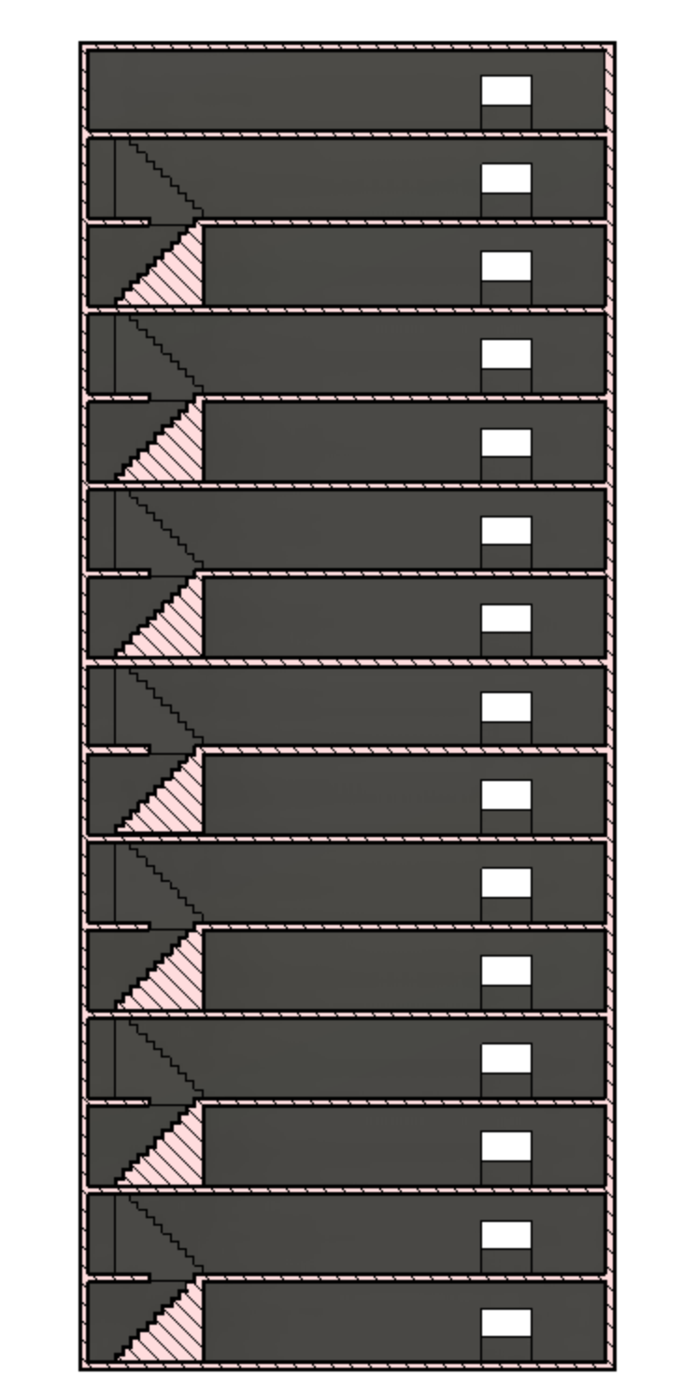

Part 2

In 4-6 sentences, identify and explain the following: What is working well in creating your ATC's/Independent Project? What struggles or difficulties have you encountered?

Our project is pretty big so we’re doing it as a pair. The game engine we’re using doesn’t offer sharing though, so we had to figure out a way to share files. Because of this, it’s hard for both of us to work on the same thing, so we’ve divided the project in two. Jane will work on the coding and movement mechanics, while Nathaniel will work on the 3D modeling. Of course, we’ll help each other out if needed. We implemented git version control to keep track of files and send them back and forth. The main challenge with the project will be to code some of the more complex game mechanics, and make sure that the buildings designed in fusion 360 will be easy to navigate in the game.

Part 3

*Projected timeline:*

**During the week of the 29th: explain (1-2 sentences)**

Jane: finish gravity

Nathaniel: make second building

**During the weekend:explain (1-2 sentences)**

Jane: fully finish movement (jumping, sprinting, gravity)

Nathaniel: unavailable during that weekend

**During the week of the 5th: explain (1-2 sentences)**

Jane: create multiplayer mode

Nathaniel: make 3rd and 4th buildings

**During the weekend:explain (1-2 sentences)**

Jane: work on shooting/health mechanics

Nathaniel: make 2 more buildings

**During the week of the 12th: explain (1-2 sentences)**

Jane: finish up anything (possibly add a crafting mechanism/ multiple guns?)

Nathaniel: make 5-6 small structures, benches, etc.

**During the weekend:explain (1-2 sentences)**

Jane: finalize all coding, fix any bugs

Nathaniel: make the in game items

**ATC/Independent Project due date: April 21st**